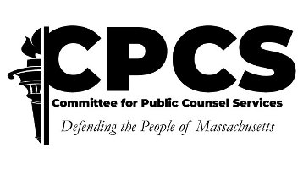

CERTIFICATE OF ATTENDANCE

PROGRAM: Upstander Advocacy in the Legal Profession
DATE: 6/17/2021
TIME: 5:30-7:30PM
LOCATION: WEBINAR
SPONSOR: Supreme Judicial Court Standing Committee on Lawyer Well-Being
CLE: 2

THIS CERTIFIES THAT THE FOLLOWING ATTENDEE HAS COMPLETED THE ABOVE-LISTED TRAINING PROGRAM:

Enter name and address

THIS CERTIFICATE SHOULD BE RETAINED BY THE PARTICIPANT AS PROOF OF ATTENDANCE
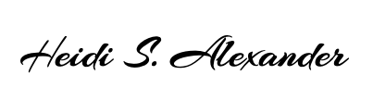

SJC Standing Committee on Lawyer Well-Being

